**NETWORKING AND SYSTEM ADMINISTRATION LAB**

**Motherboard**

A motherboard provides connectivity between the hardware components of a computer, like the processor (CPU), memory (RAM), hard drive, and video card. There are multiple types of motherboards, designed to fit different types and sizes of computers.

Each type of motherboard is designed to work with specific types of processors and memory, so they don't work with every processor and type of memory. However, hard drives are mostly universal and work with the majority of motherboards, regardless of the type or brand. 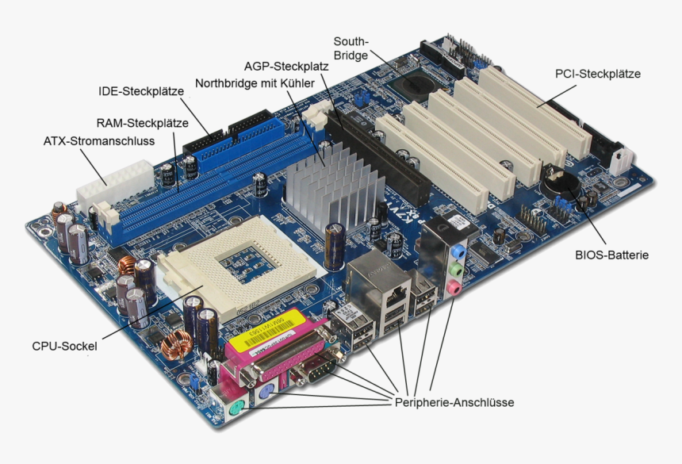

The motherboard is mounted inside the case and is securely attached via small screws through pre-drilled holes. Motherboard contains ports to connect all of the internal components. It provides a single socket for CPU, whereas for memory, normally one or more slots are available. Motherboards provide ports to attach the floppy drive, hard drive, and optical drives via ribbon cables. Motherboard carries fans and a special port designed for power supply.

There is a peripheral card slot in front of the motherboard using which video cards, sound cards, and other expansion cards can be connected to the motherboard.

On the left side, motherboards carry a number of ports to connect the monitor, printer, mouse, keyboard, speaker, and network cables. Motherboards also provide USB ports, which allow compatible devices to be connected in plug-in/plug-out fashion. For example, pen drive, digital cameras, etc.

**Memory Module** or **RAM (**[**Random-Access Memory**](https://en.wikipedia.org/wiki/Random-access_memory)**)**

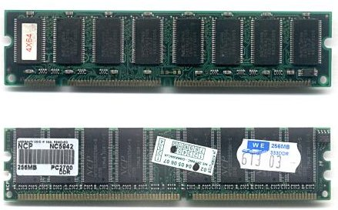

In computing, a **memory module** or **RAM (**[**random-access memory**](https://en.wikipedia.org/wiki/Random-access_memory)**) stick** is a [printed circuit board](https://en.wikipedia.org/wiki/Printed_circuit_board) on which [memory](https://en.wikipedia.org/wiki/Computer_memory) [integrated circuits](https://en.wikipedia.org/wiki/Integrated_circuit) are mounted.[[1]](https://en.wikipedia.org/wiki/Memory_module#cite_note-1) Memory modules permit easy installation and replacement in electronic systems, especially computers such as [personal computers](https://en.wikipedia.org/wiki/Personal_computer), [workstations](https://en.wikipedia.org/wiki/Workstation), and [servers](https://en.wikipedia.org/wiki/Server_(computing)). The first memory modules were proprietary designs that were specific to a model of computer from a specific manufacturer. Later, memory modules were standardized by organizations such as [JEDEC](https://en.wikipedia.org/wiki/JEDEC) and could be used in any system designed to use them.

Types of memory module include:

* [TransFlash Memory Module](https://en.wikipedia.org/wiki/TransFlash_Memory_Module)
* [SIMM](https://en.wikipedia.org/wiki/SIMM), a single in-line memory module
* [DIMM](https://en.wikipedia.org/wiki/DIMM), dual in-line memory module
  + [Rambus](https://en.wikipedia.org/wiki/Rambus) memory modules are a subset of DIMMs, but are normally referred to as RIMMs
  + [SO-DIMM](https://en.wikipedia.org/wiki/SO-DIMM), small outline DIMM, a smaller version of the DIMM, used in laptops

Distinguishing characteristics of computer memory modules include voltage, capacity, speed (i.e., [bit rate](https://en.wikipedia.org/wiki/Bit_rate)), and [form factor](https://en.wikipedia.org/wiki/Computer_form_factor). For economic reasons, the large (main) memories found in personal computers, workstations, and non-handheld game-consoles (such as PlayStation and Xbox) normally consist of dynamic RAM (DRAM). Other parts of the computer, such as [cache memories](https://en.wikipedia.org/wiki/Cache_memory) normally use [static RAM](https://en.wikipedia.org/wiki/Static_RAM) ([SRAM](https://en.wikipedia.org/wiki/Static_random_access_memory)). Small amounts of SRAM are sometimes used in the same package as DRAM.[[2]](https://en.wikipedia.org/wiki/Memory_module#cite_note-2) However, since SRAM has high leakage power and low density, [die-stacked](https://en.wikipedia.org/wiki/Three-dimensional_integrated_circuit) DRAM has recently been used for designing multi-megabyte sized processor caches.[[3]](https://en.wikipedia.org/wiki/Memory_module#cite_note-3)

Physically, most DRAM is [packaged](https://en.wikipedia.org/wiki/Integrated_circuit_packaging) in black epoxy resin.

*Daughter card*

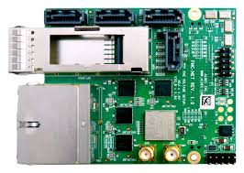

A daughterboard (or daughter board , daughter card , or daughtercard ) is a circuit board that plugs into and extends the circuitry of another circuit board. The other circuit board may be the computer's main board (its motherboard ) or it may be another board or card that is already in the computer, often a sound card. The term is commonly used by manufacturers of wavetable daughterboards that attach to existing sound cards.

A mezzanine card is a kind of daughterboard that is installed in the same plane as but on a second level above the motherboard.

Bus Slots

Alternatively known as a bus slot or expansion port, an expansion slot is a connection or port inside a [computer](https://www.computerhope.com/jargon/c/computer.htm) on the [motherboard](https://www.computerhope.com/jargon/m/mothboar.htm) or [riser card](https://www.computerhope.com/jargon/r/risecard.htm). It provides an installation point for a hardware expansion card to be connected. For example, if you wanted to install a new video card in the computer, you'd purchase a video expansion card and install that card into the compatible expansion slot.

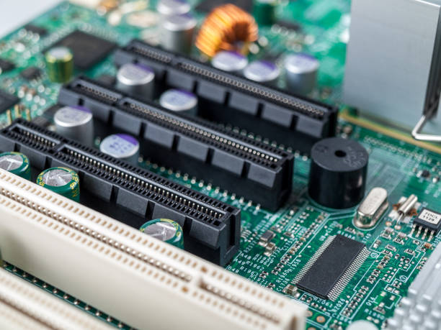

## **SMPS: Switched-Mode Power Supply/ Switching Mode Power Supply**

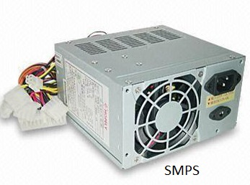

SMPS stands for Switched-Mode Power Supply. It is an electronic power supply that uses a switching regulator to convert electrical power efficiently. It is also known as Switching Mode Power Supply. It is power supply unit (PSU) generally used in computers to convert the voltage into the computer acceptable range.

This device has the power handling electronic components that converts electrical power efficiently. Switched Mode Power Supply uses a great power conversion technique to reduce overall power loss.

The SMPS device uses switching regulators that switches the load current on and off to regulate and stabilize the output voltage. The average of the voltage between the off and on produces the appropriate power for a device. Unlike the linear power supply, the pass transistor of SMPS switches between low dissipation, full-on and full-off mode, and spends very less time in the high-dissipation transitions, which minimizes wasted energy.

**STORAGE DEVICES**

There are two types of storage device used as secondary storage in computers: HDD and SSD. While HDDs are the more traditional of the two, SSDs are fast overtaking HDD as the preferred tech for secondary storage.

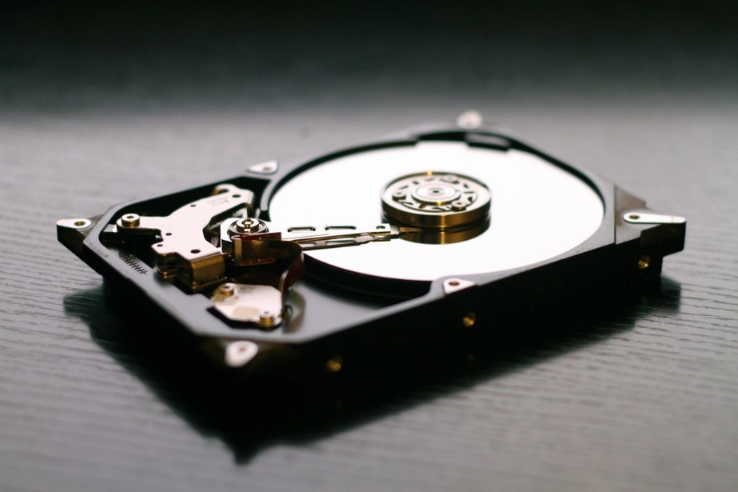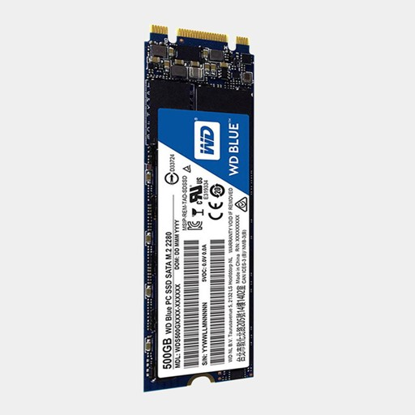

**PORTS**

A Computer Port is an interface or a point of connection between the computer and its peripheral devices. Some of the common peripherals are mouse, keyboard, monitor or display unit, printer, speaker, flash drive etc.

The main function of a computer port is to act as a point of attachment, where the cable from the peripheral can be plugged in and allows data to flow from and to the device.

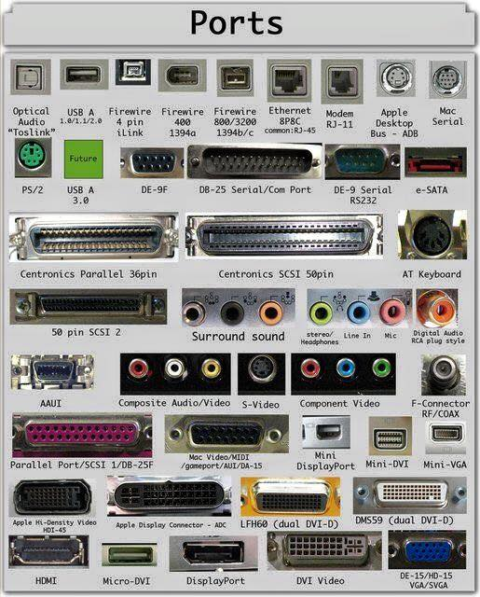

**SPECIFICATION OF DESKTOP AND SERVER CLASS COMPUTERS**

|  |  |
| --- | --- |
| Component | Specification |
| Processor: | 10th or 11th Gen Intel Core i5, i7 or i9 Processor, or Apple M1 Processor (CPU) |
| Operating System: | Microsoft Windows 10 Home, Pro, Enterprise or Education version *or* macOS 10.15.X “Catalina” or 11.X “Big Sur.” |
| Memory (RAM): | 8-16 GB of RAM |
| Storage: | 240 GB solid state drive, or larger. |
| Video/Graphics: | Integrated or Discrete graphics processor capable of 1440 X 900 resolution, or better (1920 X 1080 *or* 1200 ideal). |
| Monitor: | for notebook: 13″ – 17″ display for desktop: 19″ – 27″ widescreen flat-panel display |
| Mouse: | Built-in or external trackpad, wireless and/or USB, 2-button, optical mouse |
| Sound: | Sound card or built-in audio, and speakers |
| Headphones: | Headphones or Earbuds, with Built-in Microphone |
| Webcam: | Either external USB device or built-in |
| Network: | 802.11ac Wi-Fi capability. |

*Intel i5 & i7*

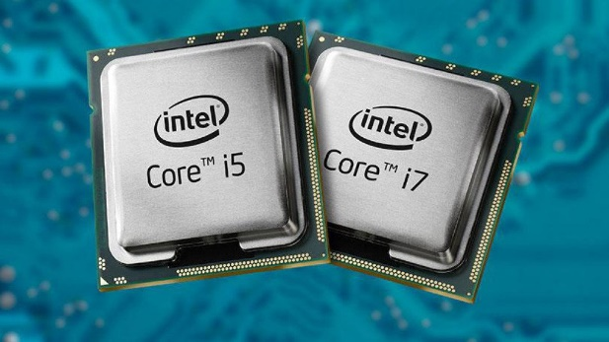

*Ryzen*

